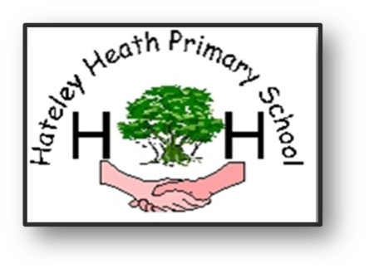

Hateley Heath Primary School

Our agreed words – Genitalia / bodies

EYFS

grown up, nose, head, fingers, arm, eyes, ear, mouth, fingers, nose, arm, grow, new baby, belly button, mouth, knees, feet, belly/ tummy, bottom, young, old, cuddle, hug, squeeze, like, dislike, adult, child, growing up, change, learn, nervous, happy, feelings.

Year 1

vagina, penis, breasts, male, female, touch, private, change, texture, responsibilities, appearance, independent, fully grown, life cycle, respect, anxious, worried, excited, physical, timeline, freedom, looking forward, adulthood.

Year 2

vulva, anus, testicles, umbilicus (Belly button), acceptable, unacceptable, comfortable, uncomfortable, nipples, teenager, toddler, control, public, coping, mature.

Year 3

clean, cleanliness, hygiene, sweat, sweat and body odour, ovary/ovaries, puberty, birth, changes, animals, babies, mother, baby, grow, nutrients, love, affection, care, change, vagina, male, female, skin and spots oily hair washing genitalia, puberty, change, grow, mature, child, teenage, adult, private parts, genitals, uterus, womb, survive, growing up, control / puberty self-esteem, self-confidence, ovaries , egg , ovum urethra, vulva, anus, labia, ova.

Year 4

periods, panty pad, body odour, spots, sanitary pads, period, sanitary protection (pads and tampons), tampons, menstruation, menstrual cycle, blood, pubic hair, producing sperm, erection, wet dream, scrotum, sperm, semen, breasts, emotions, roller coaster reproductive organs.

Year 5

Sweat, sweat and body odour, clean, cleanliness, hygiene, self, self-image, body image, self-esteem, self-confidence, puberty, menstruation, menstrual cycle, blood, periods, spots, sanitary towels, panty pad, sanitary pads, tampons, ovar, ovaries, vagina, oestrogen, vulva, womb, uterus, sperm, semen, testicles, testes, genitals, breasts, reproductive organs, washing genitalia fallopian tube, fertilisation, pregnancy, fertility treatment (IVF), embryo, umbilical cord, change, hope, manage, cope, opportunities, Emotions, fear, excitement, anxious, pubic hair, making love, sexual intercourse, hormones, relationships, conception, facial hair, growth spurt, emotions, roller coaster, up and down, frustrated, angry, moody, adolescent, advice, support, private parts, change, grow, mature, child, teenage, adult characteristics, contraception, teenager, milestone, perceptions, responsibilities, internal, inside, aspects, perception.

Year 6

Clitoris, urethra , vagina, vulva, anus, uterus, cervix, ovary, ovaries, labia, fallopian tubes, menstruation, erections, producing sperm, ejaculation, wet dreams, sanitary protection (pads and tampons), oily hair, skin and spots , adam’s apple, penis, testicles, scrotum, sperm, semen, erection, wet dream, ejaculation, larynx, affirmation, circumcision, puberty.